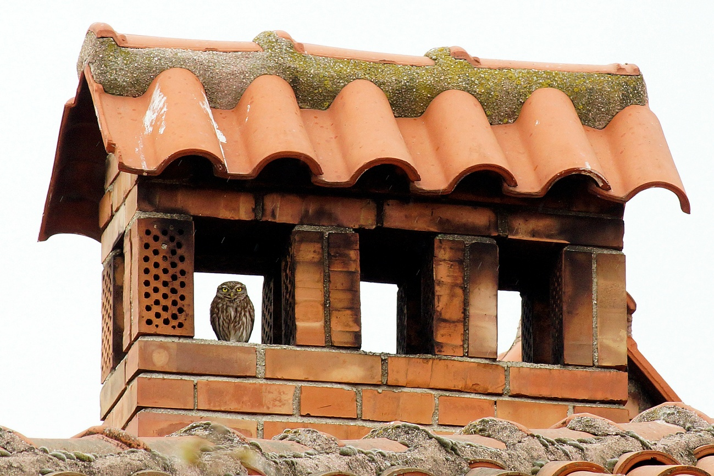

Figure S1 – Typical view of roosting Little Owl inhabiting settlements, using a covered chimney where is more safe and hidden. (Photo Assen Ignatov)

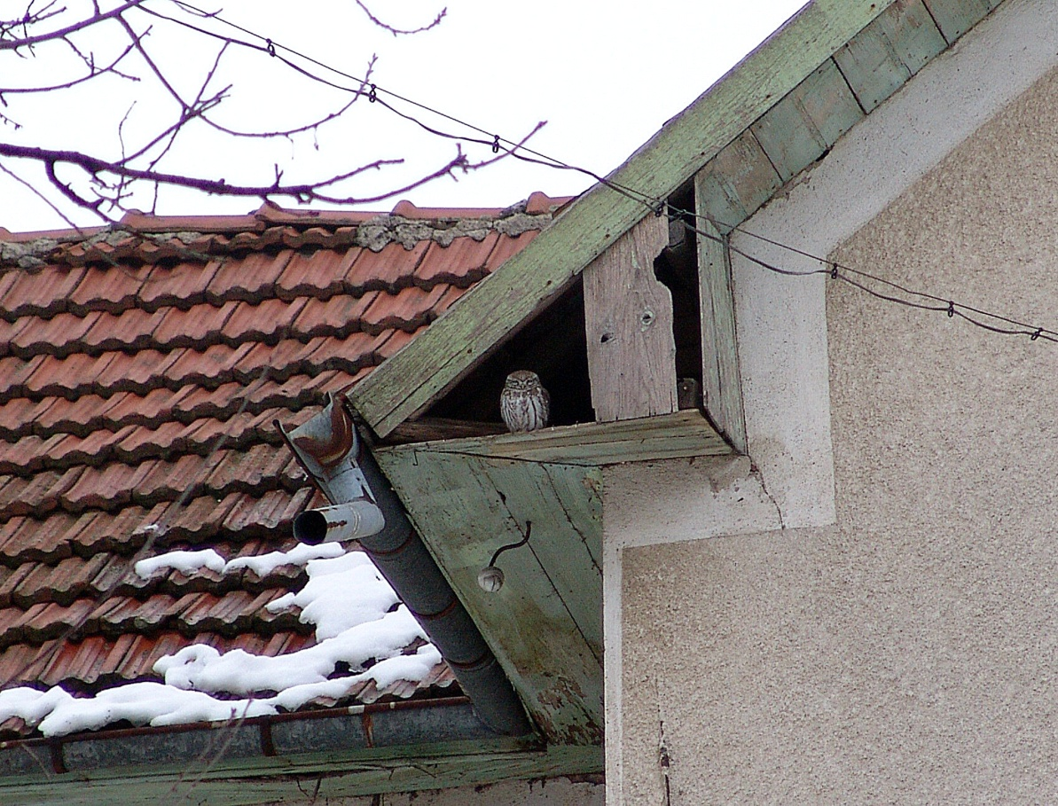

Figure S2 – Good place for Little Owls – good for roosting, breeding, hiding. (Photo Assen Ignatov)

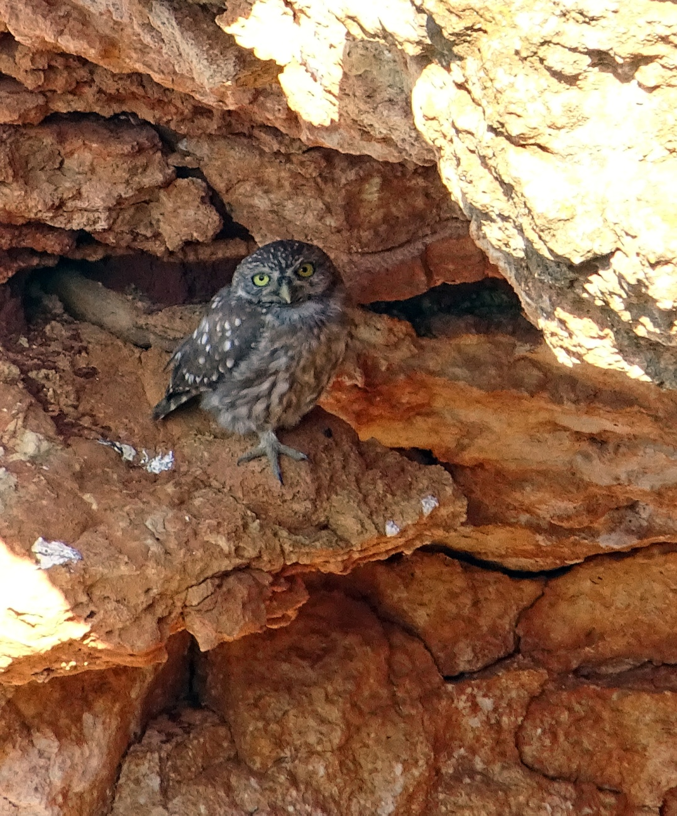

Figure S3 – Little Owl breeding on the cliffs of Cape Kaliakra, Northeastern Bulgaria (Photo Assen Ignatov)

