Appendix 1: Examples of photographs posted on the “Aves de Portugal Continental” Facebook page and used to assess avian diets in Continental Portugal.

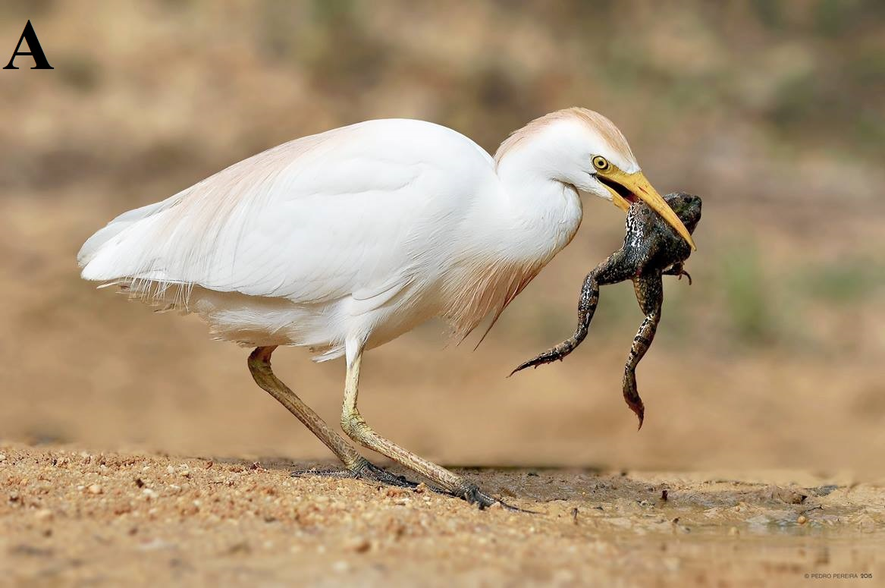
Photograph A: Cattle egret Bubulcus ibis taking an Iberian green frog Pelophylax perezi. Photograph obtained by Pedro Pereira at Ria Formosa, on 15/07/2014.
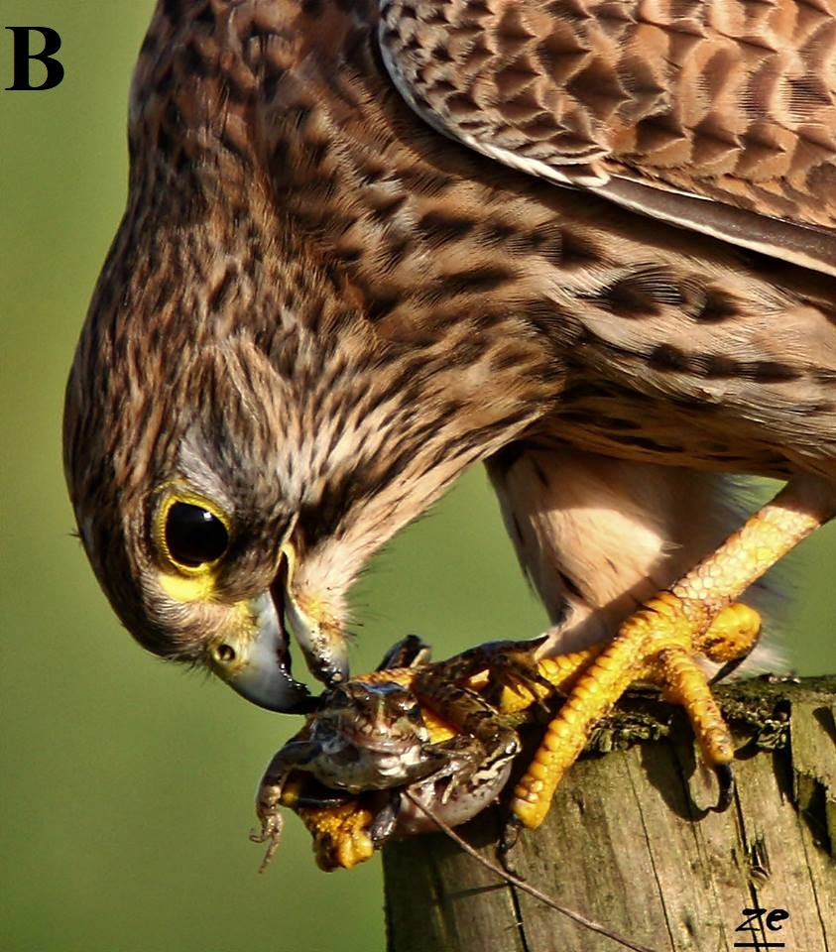
Photograph B: Common kestrel Falco tinnunculus taking an Iberian tree frog Pelophylax perezi. Photograph obtained by José Caldinhas at Ponta da Erva, on 01/12/2014.

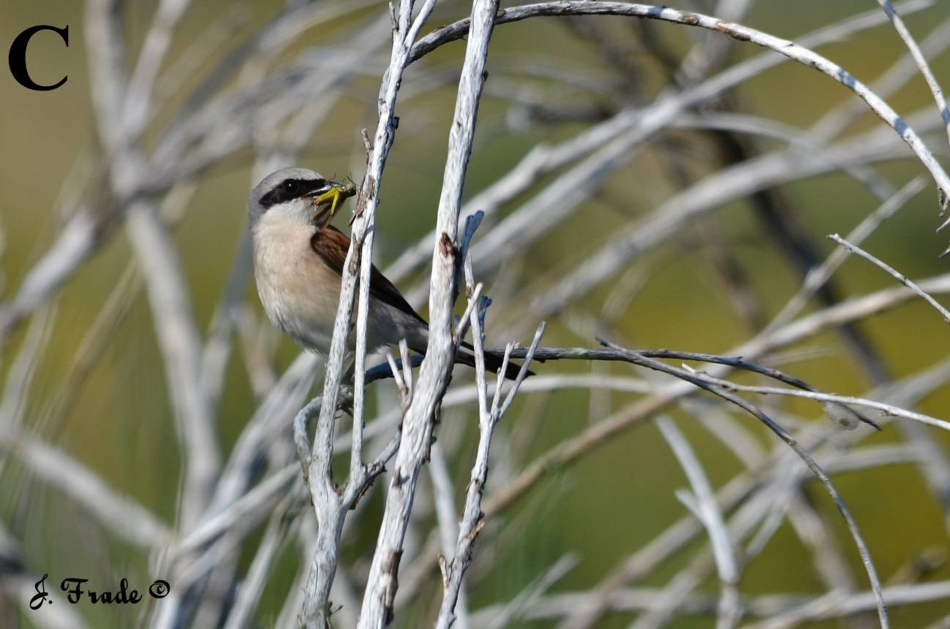
Photograph C: Red-backed shrike Lanius collurio taking an Orthopteran. Photograph obtained by José Frade in Montalegre, on 23/07/2014.

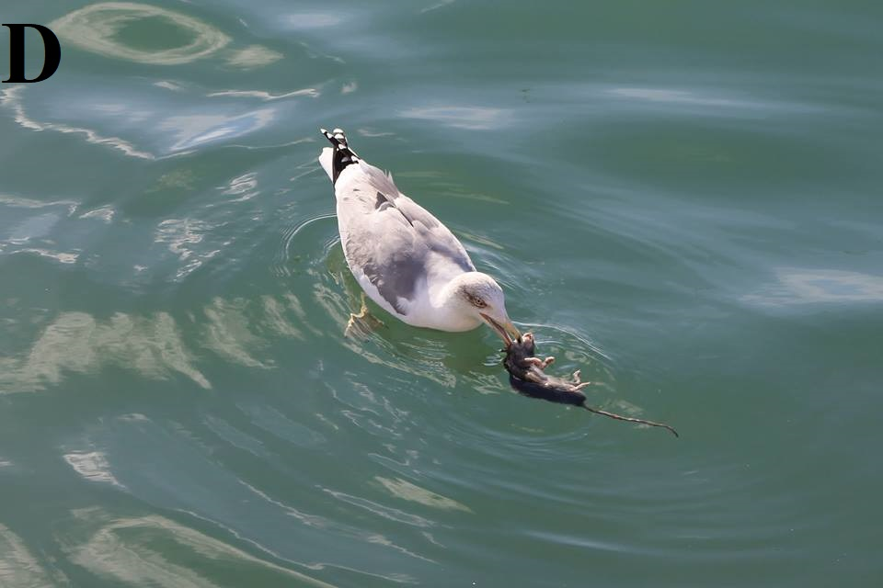
Photograph C: Yellow-legged gull Larus michahellis taking a rat Rattus sp. Photograph obtained by Ana Aguileira in Olhão, on 09/11/2016.
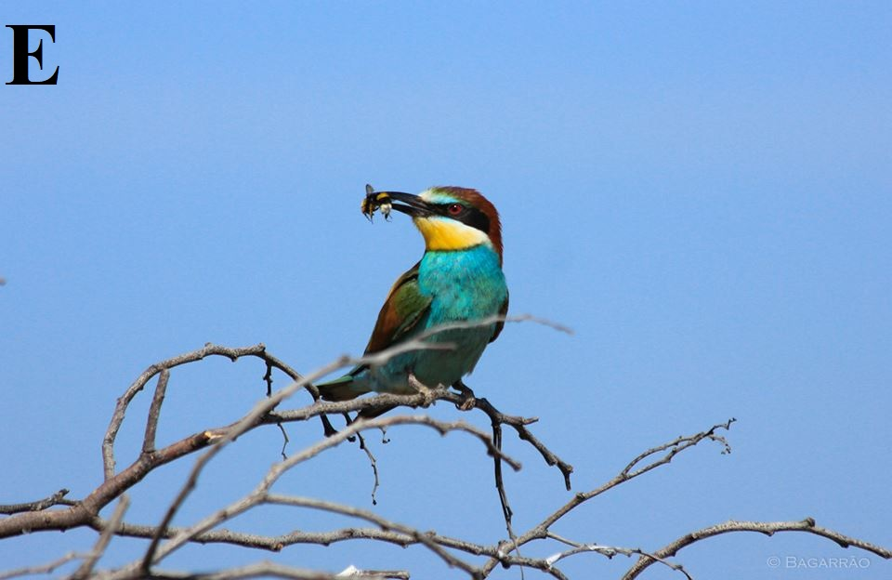
Photograph E: European bee-eater Merops apiaster taking a buff-tailed bumblebee Bombus terrestris. Photograph obtained by Renato Barragão in Tavira, on 19/05/2014.

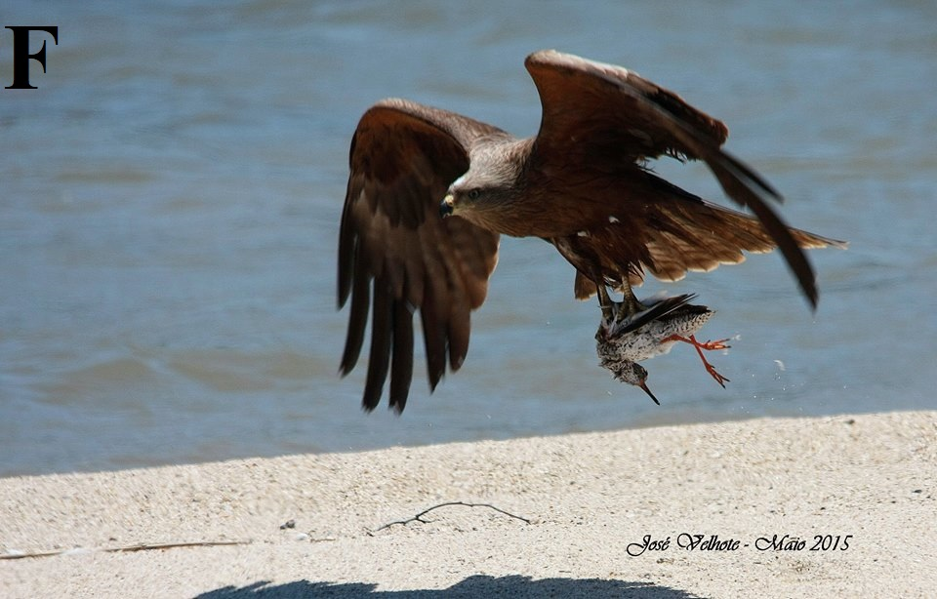
Photograph F: Black kite Milvus migrans taking a common redshank Tringa totanus. Photograph obtained by José Velhote in Vila Nova de Gaia, on 30/05/2015.

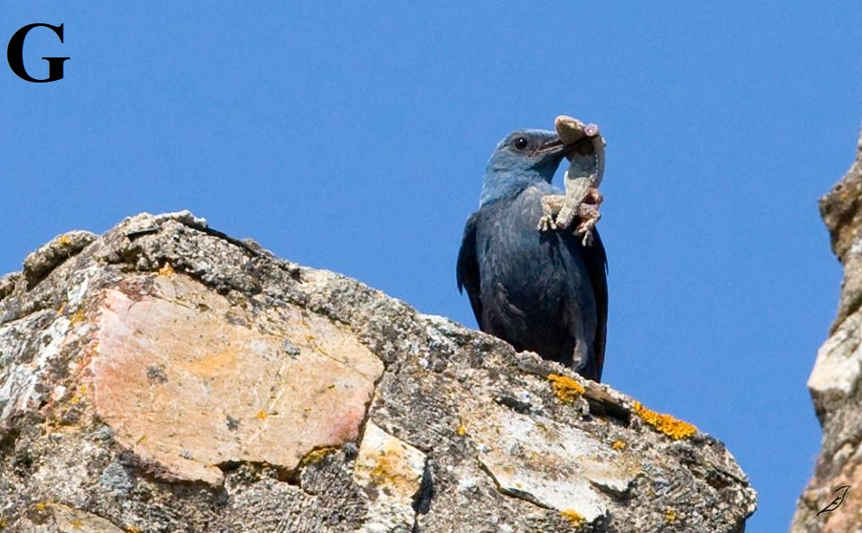
Photograph G: Blue rock-thrush Monticola solitarius taking a Moorish wall gecko Tarentola mauritanica. Photograph obtained by João Edgar in Portalegre, on 27/06/2015.

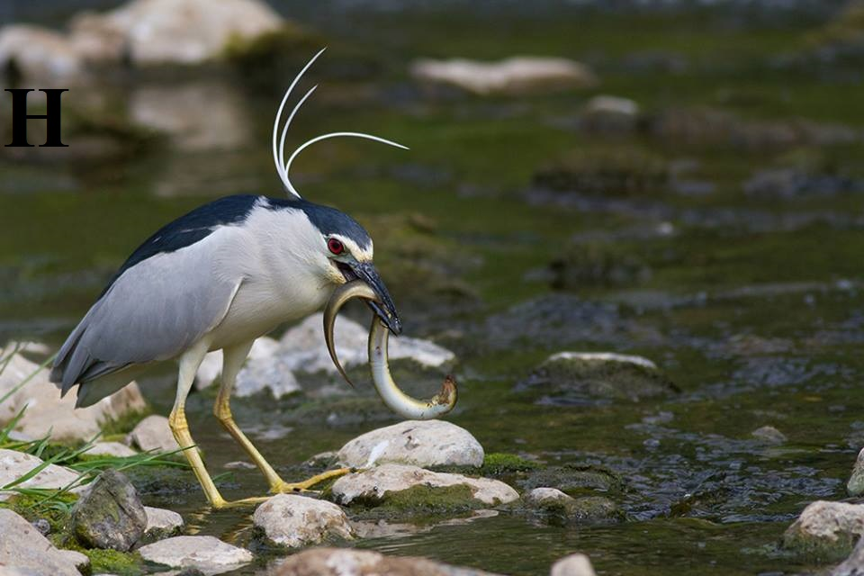
Photograph H: Black-crowned night-heron Nyctocorax nycticorax taking a European eel Anguilla anguilla. Photograph obtained by Armando Caldas in Mafra, on 09/06/2015.
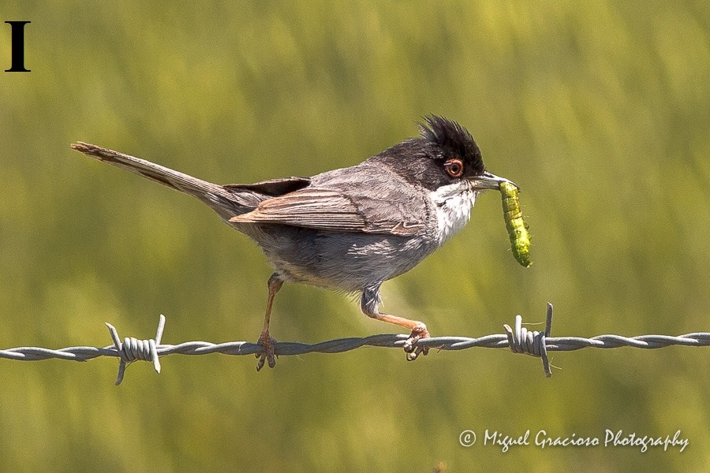
Photograph I: Sardinian warbler Sylvia melanocephala taking a Lepidopteran larvae. Photograph obtained by Miguel Gracioso at Lezíria Grande do Tejo, on 01/05/2015.

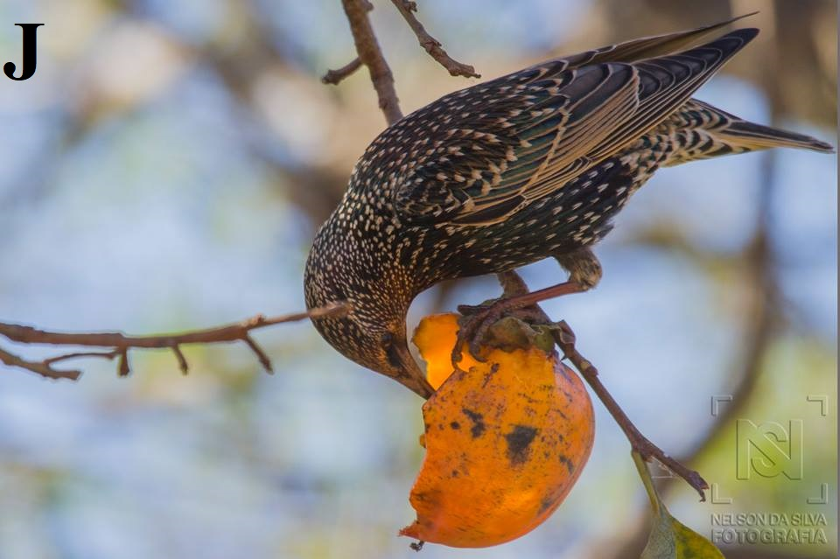
Photograph J: Common starling Sturnus vulgaris taking a persimmon Diospyrus kaki fruit. Photograph obtained by Nélson Silva at Murtosa, on 01/12/2014.

